Create a list of tuples, where the 1st element of the tuple is an int and the second

element is a string.

Example - ((1, ‘alpha’), (2, ‘beta’), (3, ‘gamma’), (4, ‘zeta’), (5, ‘omega’))

- for the above list, print the numbers where the corresponding string length is 4

**var tup = List((1,"alpla"),(2,"beta"),(3,"gamma"),(4,"zeta"),(5,"omega"))**

**tup.filter(a => a._2.length == 4).map(_._2).foreach(println)**

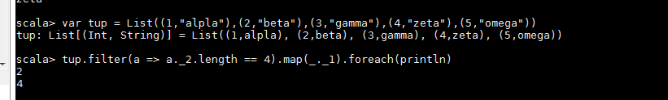

find the average of all numbers, where the corresponding string contains alphabet ‘m’

or alphabet ‘z’

**var tup = List((1,"alpla"),(2,"beta"),(3,"gamma"),(4,"zeta"),(5,"omega"))**

**var tup1 = tup.filter(a =>( a._2.count(_ == 'm') != 0 || a._2.count(_ == 'z') != 0))**

**tup1.map(_._1).sum/tup1.size**

